Posting a Vitality pre-approved social media post
- Save the image and upload to your preferred social media channel
- Copy and paste the wording of your choice as a caption into your preferred social media channel
- Use #VitalityEA. If you post on LinkedIn, make sure to tag @VitalityAdviser
- Check how your post performed throughout the day

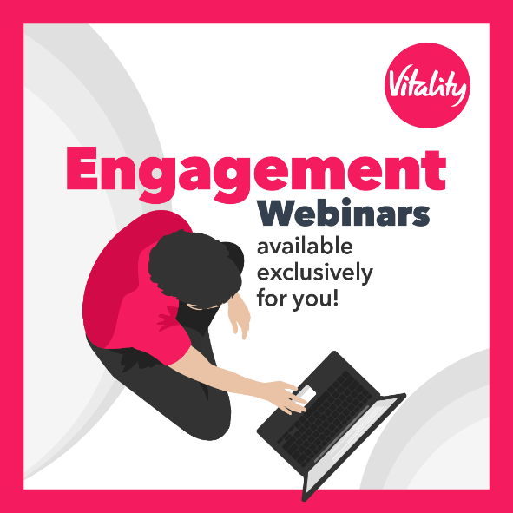
As an Exclusive Associate of Vitality, we’ve been able to give you unique access to webinars that show you how you can make the most of the Vitality Programme. Jump in and learn all you need to know about accessing discounts and rewards, whilst getting healthier and happier in the process!
To get involved contact <EA contact details> for more information.
#VitalityEA @VitalityAdviser

