Posting a Vitality pre-approved social media post
- Save the image and upload to your preferred social media channel
- Copy and paste the wording of your choice as a caption into your preferred social media channel
- Use #VitalityEA. If you post on LinkedIn, make sure to tag @VitalityAdviser
- Check how your post performed throughout the day

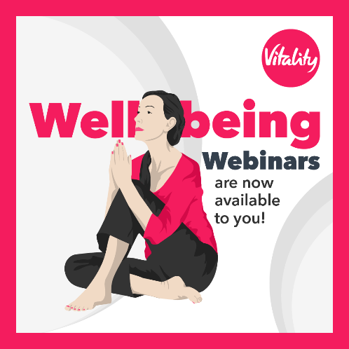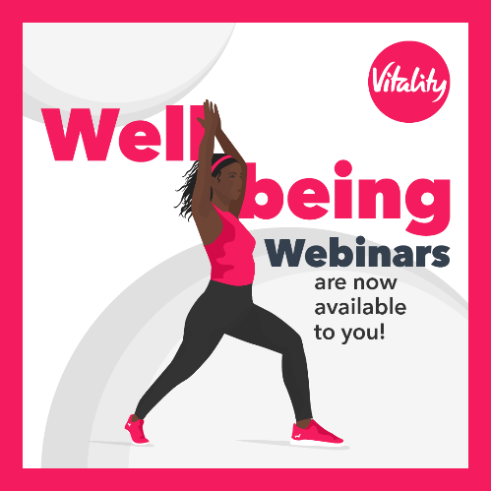
1
The Vitality Coaches are offering monthly Wellbeing Webinars to introduce simple ways to lead a healthier and happier life. To get involved contact <EA contact details> for more information. ‍️
#VitalityEA @VitalityAdviser

