Posting a Vitality pre-approved social media post
- Save the image and upload to your preferred social media channel
- Copy and paste the wording as a caption into your preferred social media channel
- Use #VitalityEA.
- If you post on LinkedIn, make sure to tag @VitalityAdviser
- Check how your post performed throughout the day

Prevention
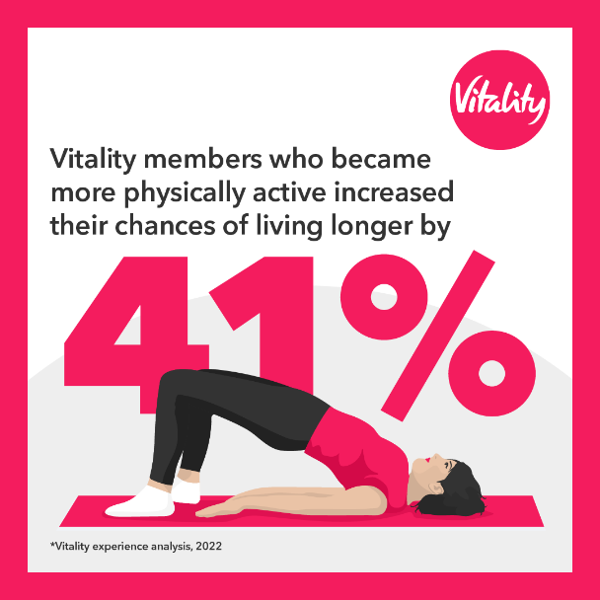
1
Vitality’s science-based approach to improving your health isn’t just so you can get savings on coffees, cinema tickets and spa getaways. Really it’s to improve your health and wellbeing so you can live healthier and happier.
#VitalityEA @VitalityAdviser

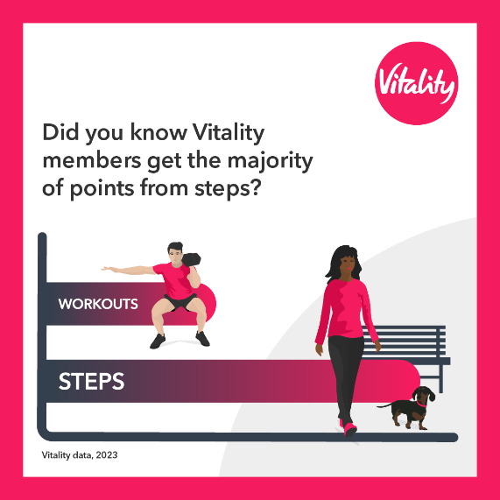
2
Walking is a simple way to stay healthy.
Many Vitality members earn rewards from tracking their step count. The healthier you are, the less likely you are to become sick or injured. But you also deserve some credit for staying healthy! ‍️

If you clock over 7,000 steps a day, four times a week, you could earn a weekly handcrafted drink from Caffè Nero or a monthly ticket at ODEON or Vue cinemas. To get a quote contact <EA contact details>.
#VitalityEA @VitalityAdviser

