Posting a Vitality pre-approved social media post
- Save the image and upload to your preferred social media channel
- Copy and paste the wording of your choice as a caption into your preferred social media channel
- Use #VitalityEA. If you post on LinkedIn, make sure to tag @VitalityAdviser
- Check how your post performed throughout the day
1
Are you concerned about being diagnosed with a later life condition, like dementia, and the associated costs?
Vitality have included Dementia and FrailCare Cover as standard with their Serious Illness Cover plans, so you and your family are supported. Contact <EA contact details> for a conversation about around cover that protects you beyond retirement.
#VitalityEA @VitalityAdviser
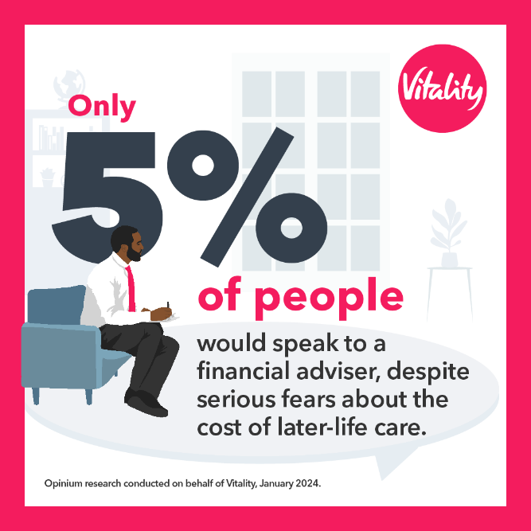

2
As a nation we’re living longer. However, these extra years may not be spent in good health. With later life conditions, like Dementia, on the rise, more of us are likely to develop a care need in later life.
To help protect you, Vitality include Dementia and FrailCare Cover as standard on all Serious Illness Cover plans. This means they cover you for longer and you and your family are supported should you be diagnosed with a later life condition .
Contact <EA contact details> to find out more about protecting yourself into later life.
#VitalityEA @VitalityAdviser
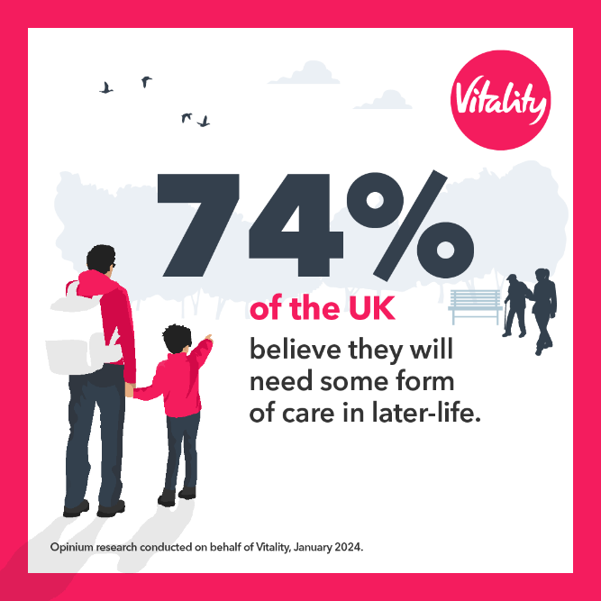

3
Being diagnosed with a later life condition can have a significant financial impact to anyone. Research shows that the typical costs of someone living with dementia are around £100,000, and this is likely to continue rising.
Vitality are the only provider to support you into later life, through their Dementia and FrailCare Cover. It pays out a lump sum if you were to be diagnosed with a later life condition, which you can use to help cover any associated costs. 💰
Contact <EA contact details> to find out how Vitality could support you.
#VitalityEA @VitalityAdviser
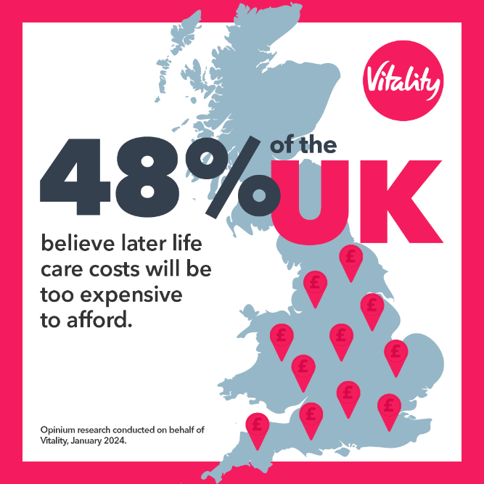

4
Want to protect yourself and your family against rising costs of later life conditions in the future?
Check out Vitality’s Serious Illness Cover which includes later life protection as part of your plan. To find out more get in touch with <EA contact details>.
#VitalityEA @VitalityAdviser
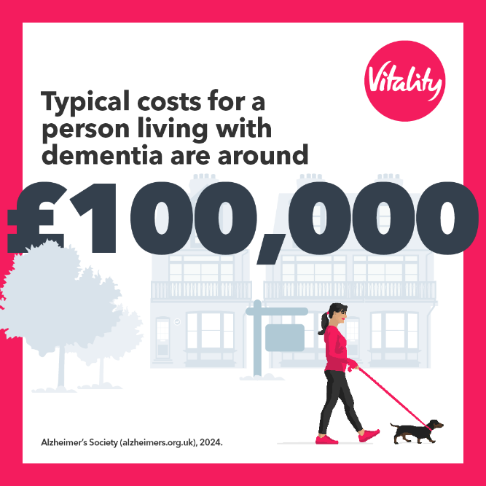

VL SM 0283

