Posting a Vitality pre-approved social media post
- Save the image and upload to your preferred social media channel
- Copy and paste the wording of your choice as a caption into your preferred social media channel
- Use #VitalityEA. If you post on LinkedIn, make sure to tag @VitalityAdviser
- Check how your post performed throughout the day
Serious Illness Cover 2024
Industry/Serious Illness Cover USPs
1
Thinking about some kind of cover in case you get ill ❓
Vitality can cover you against =
✅ More conditions than any other insurer – up to 174
✅ Up to 60 conditions not covered by any other insurer
✅ Later life cover for dementia and frailty
The best bit? Your cover also stays in place even after a full payout, so you can use it more than once.
To check prices, get in touch with <EA contact details>.
#VitalityEA @VitalityAdviser
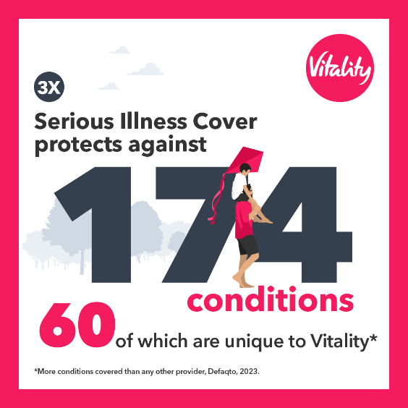

2
When you make a claim on a critical illness cover plan, your plan ends and you may find it difficult to find cover elsewhere 🤒
And the chances are, you're more likely to claim when you get older.
That’s where Vitality’s Serious Illness Cover can help as it lets you claim multiple times in full. To check prices, contact <EA contact details>.
#VitalityEA @VitalityAdviser
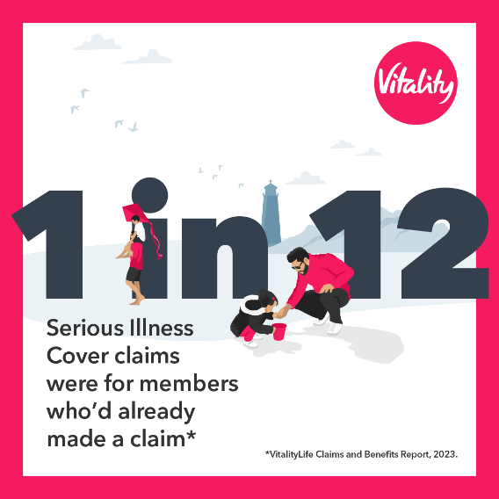

3
Do you have a plan in place in case you’re too sick to work? ‍‍
Vitality Serious Illness Cover is designed to reflect modern trends in medicine and illness. That means it’s set up to comprehensively protect you and your loved ones for longer. To get more info, contact <EA contact details>.
#VitalityEA @VitalityAdviser
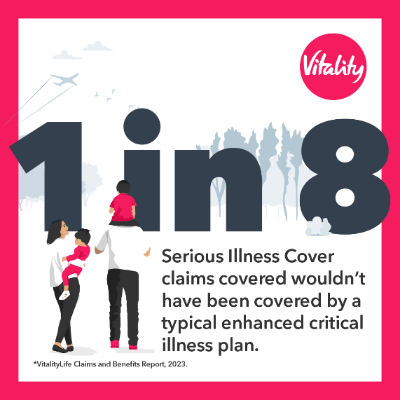

4
Do you prioritise your health and financial wellbeing?
Vitality Serious Illness Cover is just one way to keep you and your family protected. It covers you against more conditions than any other insurer. And also lets you claim multiple times in full for multiple illnesses.
To get more info, get in touch with <EA contact details>.
#VitalityEA @VitalityAdviser

5
Have you thought about insurance cover if you get ill and can't work?
Vitality Serious Illness Cover covers serious illnesses, not just critical ones, which means you don’t have to wait until your illness is life-threatening before you make a claim. To find out more, get in touch with <EA contact details>.
#VitalityEA @VitalityAdviser
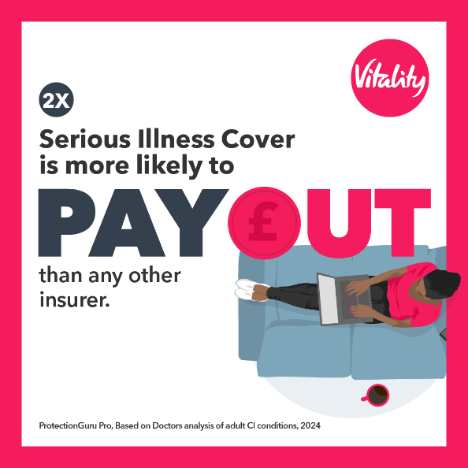
Serious Illness Cover general
6
Every penny matters right now. But there are some things that are essential for you and your loved ones
Especially if you were ever too ill to support your family.
Vitality Serious Illness Cover can protect you against more conditions than any other insurer.
To check prices more, get in touch with <EA contact details>. 📞
#VitalityEA @VitalityAdviser
7
Don’t let an unexpected health condition catch you off-guard.
Protect yourself and your loved ones with Vitality’s comprehensive Serious Illness Cover. It even lets you make multiple claims in full for multiple illnesses, unlike other insurers.
Get in touch with <EA contact details> to get more info.
#VitalityEA @VitalityAdviser
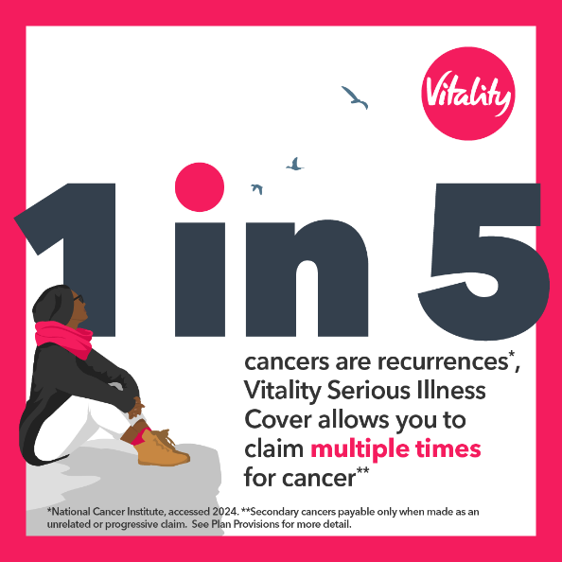
Serious Illness Cover 1X
8
19 conditions covered by Vitality’s Serious Illness Cover 1X are not covered anywhere else.
If you need insurance that’s more likely to payout than a typical critical illness plan, contact <EA contact details> for more information.
#VitalityEA @VitalityAdviser
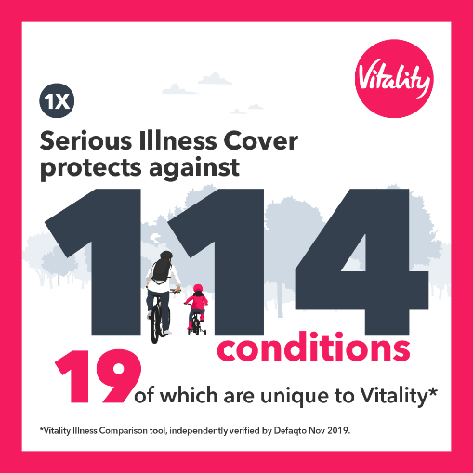

9
Need to save on your insurance, without compromising on cover?
Vitality Serious Illness Cover can:
✅ Protect you against more conditions than any other insurer
✅ Let you claim multiple times for multiple illnesses
✅ Cover you in later life for conditions like dementia and Alzheimer’s
To check prices, contact <EA contact details>
#VitalityEA @VitalityAdviser
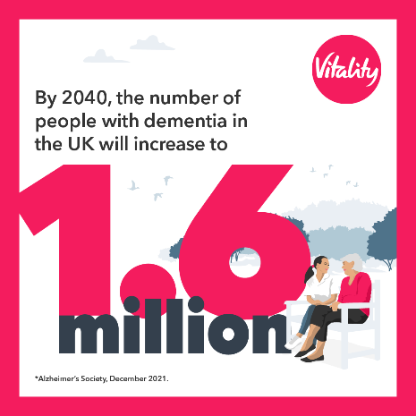

Serious Illness Cover 2X
10
We need to talk about Vitality Serious Illness Cover 2X. It’s a gamechanger.
✅ More conditions than any other insurer
✅ Lets you claim multiple times for multiple illnesses
✅ Covers you in later life for conditions like dementia and Alzheimer’s
If you want insurance that’s more likely to pay out than any other critical illness plan, with more conditions paid in full, get in touch with <EA contact details>
#VitalityEA @VitalityAdviser

11
Vitality Serious Illness Cover 2X has your back: 💪
✅ Covers you for more conditions than any other insurer
✅ 74 conditions covered in full
✅ It stays in place even after a full payout
✅ Protects you in later life against conditions like dementia
For more information, chat with me at <EA contact details>.
#VitalityEA @VitalityAdviser
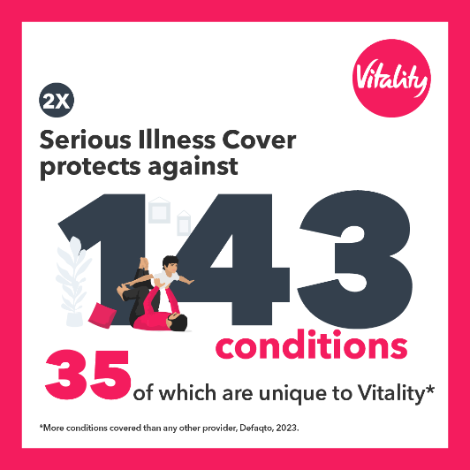

Serious Illness Cover 3X
12
You can’t control everything that happens to you. But you can control how you prepare
With Vitality’s Serious Illness Cover 3X, you’re covered for 60 conditions that are unique to Vitality.
So, if you want insurance that is more likely to pay out in the market, with more conditions paid in full, get in touch with <EA contact details> for more information
#VitalityEA @VitalityAdviser

13
Vitality has the widest cover available.
✅ More conditions covered than any other insurer – up to 174
✅ Up to 60 conditions not covered by any other insurer
✅ Later life cover for dementia
To find out about Vitality Serious Illness Cover 3X, get in touch with <EA contact details>
#VitalityEA @VitalityAdviser

Dementia and Frail cover
14
Thanks to modern medicine, we’re living longer. But you can’t guarantee to spend all those years in good health 🤕.
With a Vitality Serious Illness Cover plan, you get later life cover, included as standard. It pays out a tax-free lump sum if you’re ever diagnosed with a condition, such as dementia or Parkinson’s.
To get protected, contact <EA contact details> for more info.
#VitalityEA @VitalityAdviser
